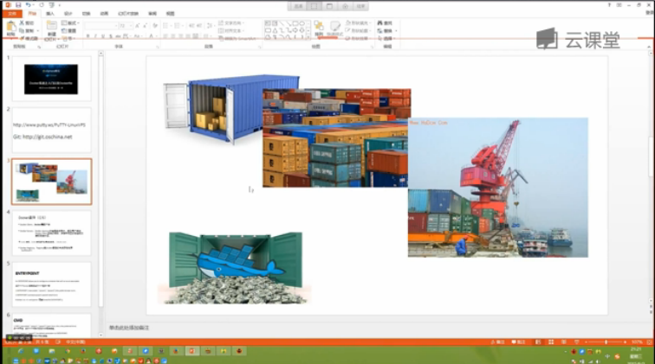

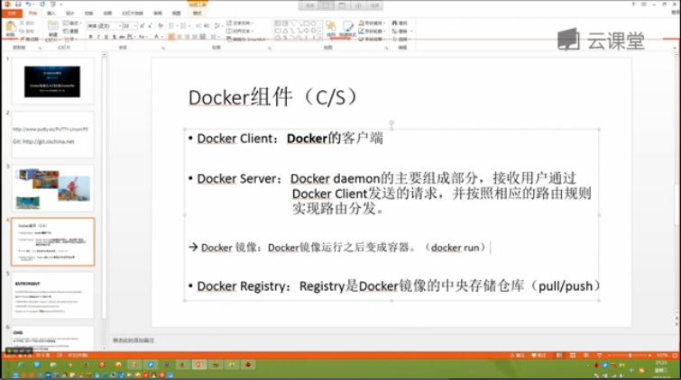

克隆docker-training 到本地

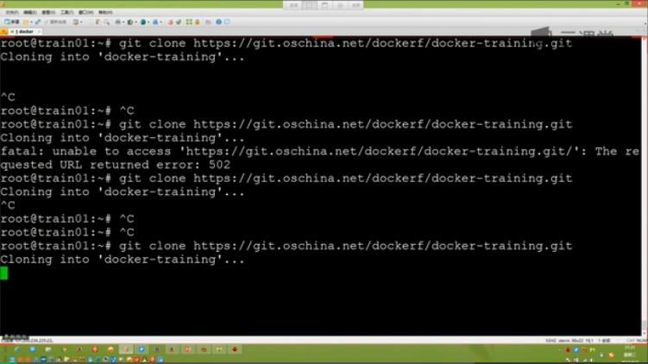

进入到docker-training目录

[root@master docker-training]# cd ..

[root@master git_files]# ls

docker-training

[root@master git_files]# cd docker-training/

[root@master docker-training]# ls

centos7 mysql php-fpm README.md wordpress

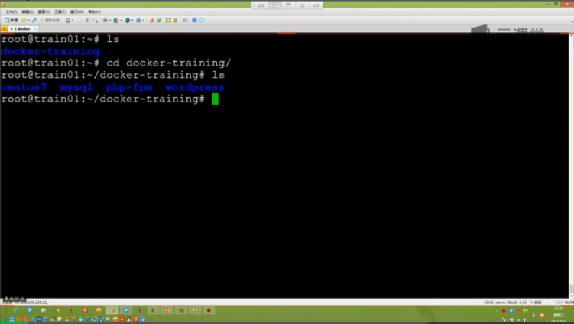

进入到centos7目录：

[root@master docker-training]# cd centos7/

[root@master centos7]# ls

aliyun-epel.repo aliyun-mirror.repo Dockerfile supervisord.conf

[root@master centos7]#

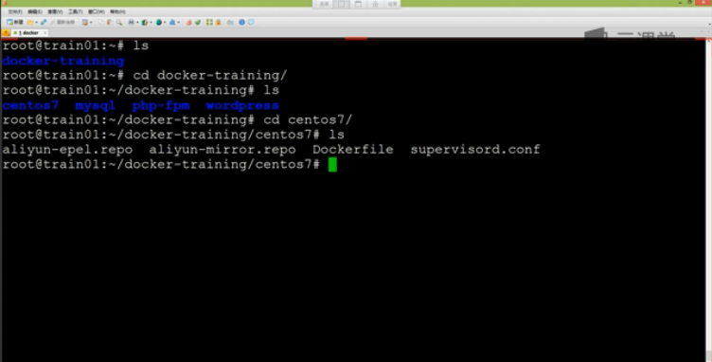

查看Dockerfile文件：

#

# MAINTAINER Carson,C.J.Zeong <zcy@nicescale.com>

# DOCKER-VERSION 1.6.2

#

# Dockerizing CentOS7: Dockerfile for building CentOS images

#

FROM centos:centos7.1.1503 ##基础镜像，也成为父镜像

MAINTAINER Carson,C.J.Zeong [<zcy@nicescale.com>](mailto:<zcy@nicescale.com>) #镜像的维护者

ENV TZ "Asia/Shanghai" #环境变量-时区

ENV TERM xterm #环境变量

ADD aliyun-mirror.repo /etc/yum.repos.d/CentOS-Base.repo #add文件到container

ADD aliyun-epel.repo /etc/yum.repos.d/epel.repo #add文件到container

RUN yum install -y curl wget tar bzip2 unzip vim-enhanced passwd sudo yum-utils hostname net-tools rsync man && \

yum install -y gcc gcc-c++ git make automake cmake patch logrotate python-devel libpng-devel libjpeg-devel && \

yum install -y --enablerepo=epel pwgen python-pip && \

yum clean all ##安装基础软件工具

RUN pip install supervisor ##进程管理工具

ADD supervisord.conf /etc/supervisord.conf ##添加主配置文件到etc下

RUN mkdir -p /etc/supervisor.conf.d && \ #存放配置文件

mkdir -p /var/log/supervisor #存放supervisor日志文件

EXPOSE 22 ##暴露端口

ENTRYPOINT ["/usr/bin/supervisord", "-n", "-c", "/etc/supervisord.conf"]

生成第一个docker镜像：

[root@master centos7]# docker build -t csphere/centos:7.1 . #最后的.代表dockerfile所在的目录

Sending build context to Docker daemon 8.704 kB

Sending build context to Docker daemon

Step 0 : FROM centos:centos7.1.1503

centos7.1.1503: Pulling from centos

d8ebe5f87416: Pull complete

47a77536ad4c: Pull complete

3690474eb5b4: Already exists

Digest: sha256:94537e256bac85f1afaf1af25863659c2251d2dcd9b039253bcebd324d656c44

Status: Downloaded newer image for centos:centos7.1.1503

---> 47a77536ad4c

Step 1 : MAINTAINER Carson,C.J.Zeong <zcy@nicescale.com>

---> Running in b0b35105ae86

---> 9d7d0c58ee1b

Removing intermediate container b0b35105ae86

Step 2 : ENV TZ "Asia/Shanghai"

---> Running in c805f05c8440

---> a797e1b41b93

Removing intermediate container c805f05c8440

Step 3 : ENV TERM xterm

---> Running in 569a96c60838

---> 8e5edf7229fd

Removing intermediate container 569a96c60838

Step 4 : ADD aliyun-mirror.repo /etc/yum.repos.d/CentOS-Base.repo

---> 10c0076691cd

Removing intermediate container 96f737743705

Step 5 : ADD aliyun-epel.repo /etc/yum.repos.d/epel.repo

---> 151b53cc3465

Removing intermediate container f40249b36d84

Step 6 : RUN yum install -y curl wget tar bzip2 unzip vim-enhanced passwd sudo yum-utils hostname net-tools rsync man && yum install -y gcc gcc-c++ git make automake cmake patch logrotate python-devel libpng-devel libjpeg-devel && yum install -y --enablerepo=epel pwgen python-pip && yum clean all

---> Running in 30df293907ef

...

[root@master centos7]#

[root@master centos7]# docker images

REPOSITORY TAG IMAGE ID CREATED VIRTUAL SIZE

<none> <none> 151b53cc3465 About a minute ago 212.1 MB

test_export_import test ca2df896129c 28 hours ago 196.5 MB

centos new_image 5b4e78623834 30 hours ago 361.1 MB

centos latest 97cad5e16cb6 2 weeks ago 196.5 MB

busybox latest 9967c5ad88de 6 weeks ago 1.093 MB

centos centos7.1.1503 47a77536ad4c 11 weeks ago 212.1 MB

tutum/mongodb latest d585332a8245 9 months ago 502.8 MB

[root@master centos7]#

Docker run -d -P 2222:22 ##宿主机2222端口映射容器的22端口，-d表示后台运行

Docker run -d -p 2222:22 ##宿主机的2222端口总是映射到容器的22端口

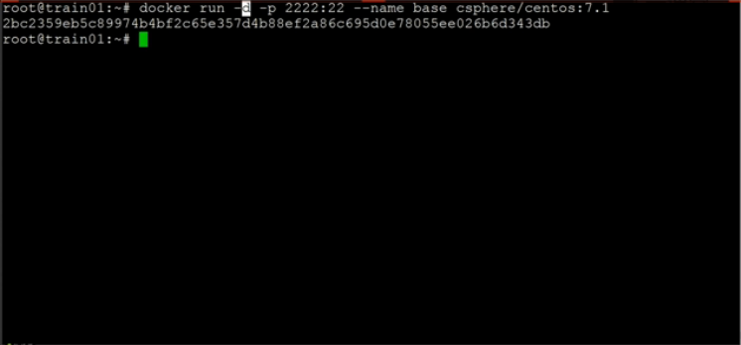

Docker ps -l

Docker ps -a

构建docker镜像：

基础镜像-->中间层镜像-->最终的应用镜像

构建php-form镜像

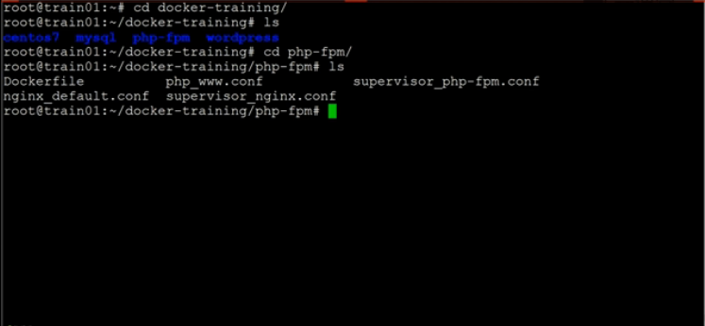

查看 dockerfile:

#

# MAINTAINER Carson,C.J.Zeong <zcy@nicescale.com>

# DOCKER-VERSION 1.6.2

#

# Dockerizing php-fpm: Dockerfile for building php-fpm images

#

FROM csphere/centos:7.1 #基础镜像

MAINTAINER Carson,C.J.Zeong [<zcy@nicescale.com>](mailto:<zcy@nicescale.com>) #镜像维护者

# Set environment variable

ENV APP_DIR /app #环境 变量

RUN yum -y swap -- remove fakesystemd -- install systemd systemd-libs && \

yum -y install nginx php-cli php-mysql php-pear php-ldap php-mbstring php-soap php-dom php-gd php-xmlrpc php-fpm php-mcrypt && \

yum clean all ##安装nginx和php-pear 并进行相应的修改

ADD nginx_nginx.conf /etc/nginx/nginx.conf

ADD nginx_default.conf /etc/nginx/conf.d/default.conf

ADD php_www.conf /etc/php-fpm.d/www.conf

RUN sed -i 's/;cgi.fix_pathinfo=1/cgi.fix_pathinfo=0/' /etc/php.ini

RUN mkdir -p /app && echo "<?php phpinfo(); ?>" > ${APP_DIR}/info.php

EXPOSE 80 443 #暴露端口号

ADD supervisor_nginx.conf /etc/supervisor.conf.d/nginx.conf

ADD supervisor_php-fpm.conf /etc/supervisor.conf.d/php-fpm.conf

ONBUILD ADD . /app ##添加onbuild指令

ONBUILD RUN chown -R nginx:nginx /app

Docker exec -it website /bin/bash #进入交互模式